Agent: Gas Leakage detection
Introduction: A Gas Leakage Detection and Automatic Shut-Off Agent is an automated safety system designed to detect gas leakage and take immediate action.
Problem Statement: Gas leakage is a common household safety problem that may go unnoticed, especially when people are not present in the kitchen or nearby.
Problem Formulation: The problem can be formulated as an environment monitoring and decision-making problem. The agent receives gas-level readings from a gas sensor and compares them with a predefined safe limit.
Problem Solution: The proposed solution is an automated rule-based agent that continuously monitors gas sensor data.
The agent follows these steps:
Gas Sensor → Read Gas Level → Apply Rule → Detect Leakage → Shut Valve + Alarm + Warning.
Decision Rules:
IF gas level > safe limit
THEN
Gas Leakage = Detected
Gas Valve = OFF
Alarm = ON
Warning Message = "Gas Leakage Detected!"
Else : Normal
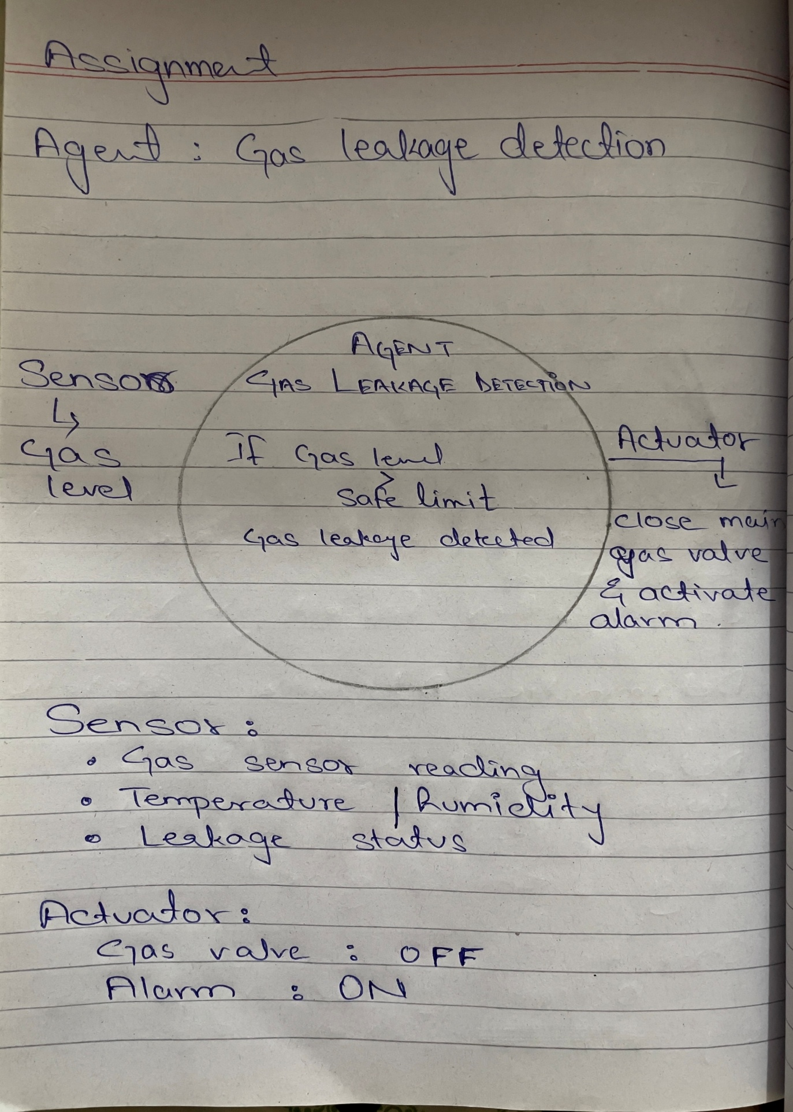
PEAS Framework:
Performance: Detect leakage accurately, respond quickly
Environment: Kitchen
Actuators: Automatic gas shut-off valve
Sensors: Gas leakage sensor
Property | Type | Why
Observability | Partially Observable | The agent can't see the full real picture of the envirnonment..
Determinism | Stochastic | Gas concentration and leakage conditions can change unpredictably.
Episodes | Episodic | Each gas detecTion event can be handled on its own.
Change | Dynamic | The gas level can change at any time while the agent is monitoring the environment.
Values | Continuous | Gas concentraTion can have many different numerical values.
Agents | Single Agent | The gas leakage detector acts as the main agent monitoring the environment.

ASSIGMENT: RULE BASE AGENT
SUBMITTED BY: SYED SHUJA RAZA
ROLL NO: 23122169
SECTION:BSCS-06 (C)
COURSE: ARTIFICIAL INTELLIGENCE

